**THE CODE:**

|  |
| --- |
| **#**include <iostream>  #include <fstream> //FOR FILE HANDLING  #include <string>  #include <conio.h>  #include <stdio.h>  using namespace std;  //CLASS FOR THE DATAS OF USERS  class Data {  public:  int accNum;  string lName;  string fName;  string bal;  };  //IO FILES  //ofstream outFile("data.txt", std::ios_base::app);  //ifstream inFile ("data.txt", std::ios_base::app);  //ofstream fileTemp ("datatemp.txt",std::ios_base::app);  //ifstream accFile("accounts.txt",std::ios_base::app);  int choice;  //FUNCTIONS  void writeRec(); // TO WRITE THE RECORD  void readRec(); // READ THE RECORD  void searchRec(); // SEARCH THE RECORDS  void editRec();// EDIT A RECORD  void delRec(); // DELETE A RECORD  int main(){  while(1){    // it must contain account number, first name, last name and balance  cout << "1 - Write Record\n";  // read the record using the account number  cout << "2 - Read Record\n";  // search the record using the account number  cout << "3 - Search Record\n";  // search using the account number  cout << "4 - Edit Record\n";  // edit record using the account number  cout << "5 - Delete Record\n";  // delete record using account number  cout << "6 - Exit\n\n";  cout << "Your Choice: ";  cin >> choice;  system("cls");  switch(choice){  case 1:  writeRec();  system("cls");  break;  case 2:  readRec();  system("cls");  break;  case 3:  searchRec();  system("cls");  break;  case 4:  editRec();  system("cls");  break;  case 5:  delRec();  break;  case 6:  system("cls");  return 0;  break;  default:  cout << "Invalid key. Please Try again!:";  system("pause");  system("cls");  break;    }  }  }  void writeRec(){  ofstream outFile("data.txt", std::ios_base::app);  ofstream outaccFile("accounts.txt",std::ios_base::app);  Data info; // CALLING THE CLASS  //ASKING FOR INPUTS  cout << "Account number: ";  cin >> info.accNum;  outFile<< info.accNum << endl;  outaccFile << info.accNum << endl;  cout << "First Name: ";  cin >> info.fName;  outFile << info.fName << endl;  cout << "Last Name: ";  cin >> info.lName;  outFile << info.lName<< endl;  cout << "Balance: ";  cin >> info.bal;  outFile << info.bal<< endl;  outFile.close();  }  void readRec(){  ifstream inFile ("data.txt", std::ios_base::app);  string line;  string accNum2;  cout << "Enter the Account Number: ";  cin >> accNum2;  // THIS WILL SEARCH THOURGH EVERY LINE  // UNTIL IT FOUNDS THE ACC NUMBER  // AFTER 3 LINES OF ACC NUMBER,  // IT WILL BE OUTPUTED  while (!inFile.eof()){  inFile >> line;  if(accNum2 == line){  for (int i=0;i < 3;i++){  inFile >> line;  if(i==0)  cout << "First Name: " << line << endl;  else if (i==1)  cout << "Last Name: " << line << endl;  else  cout << "Balance: " << line << endl;  }  system("pause");  }  }  inFile.close();  }  void searchRec(){  ifstream accFile("accounts.txt",std::ios_base::app);  string accNum2;  string search;  cout << "Enter the Account Number: ";  cin >> search;  // WILL SEARCH THOURGH EVERY LINE IN THE ACCOUNT.TXT  // THEN IT WILL CHECK FOR EQUALITY  while (!accFile.eof()){  accFile >> accNum2;  if (search == accNum2){  cout << "Record Found!\n";  system("pause");  break;  } else if (accFile.eof()){  cout << "Record Not Found!\n";  system("pause");  break;  }  }  accFile.close();  }  void editRec(){  ifstream inFile ("data.txt", std::ios_base::app);  ofstream fileTemp ("datatemp.txt",std::ios_base::app);  Data info2;  string line1;  string accNum3;  string strTemp[3];  // ASKING FOR NEW INPUTS  cout << "Enter the Account Number: ";  cin >> accNum3;  string strReplace[3];  string strNew[3];  cout << "New First Name: ";  cin >> info2.fName;  strNew[0] = info2.fName;  cout << "New Last Name: ";  cin >> info2.lName;  strNew[1] = info2.lName;  cout << "New Balance: ";  cin >> info2.bal;  strNew[2] = info2.bal;  // THIS WILL SEARCH THE TXT FILE  // AND THEN WILL FIND THE ACC NUMBER  // AND AFTER THE 3 LINES OF ACC NUM,  // IT WILL BE EDITED AND  // ALL THE NEW DATA WILL BE SAVED TO A NEW TXT FILE  for(int i = 0 ; i < 3;i ++){  strReplace[i] == strNew[i];  }  string line2;  while (!inFile.eof()){  inFile >> line2;  if(accNum3 == line2){    fileTemp << accNum3 << endl;  for (int i=0;i < 3;i++){  fileTemp << strNew[i]<<endl;  inFile >> line2;  }  }  else if (accNum3 != line2){  fileTemp << line2 << endl;  }  }  // TO RENAME AND REMOVE THE TXT FILE  inFile.close();  fileTemp.close();  system("del.\\data.txt");  system("ren.\\datatemp.txt data.txt");  cout << "Successfully edited the account!\n";  system("pause");  }  void delRec() {  //to overwrite accounts.txt  ifstream accFile("accounts.txt",std::ios_base::app);  ofstream outaccFile("accountstemp.txt",std::ios_base::app);  //to also overwrite data.txt  ifstream inFile ("data.txt", std::ios_base::app);  ofstream fileTemp ("datatemp.txt",std::ios_base::app);  string line3;  cout << "Enter Account Number: ";  string accNum;  cin >> accNum;  while(!inFile.eof()){  inFile >> line3;  if(line3==accNum){  for(int i =0;i < 4 ;i++){  inFile >> line3;  }  } fileTemp << line3 << endl;    }  //to delete accnumber in accounts.txt  string acc;  while (!accFile.eof()){  accFile >> acc;  if (acc == accNum){  accFile >> acc;  }  outaccFile << acc << endl;  }    //close all files  inFile.close();  fileTemp.close();  outaccFile.close();  accFile.close();  //to rename and delete the files to complete overwrite  system("del.\\accounts.txt");  system("ren.\\accountstemp.txt accounts.txt");  system("del.\\data.txt");  system("ren.\\datatemp.txt data.txt");  cout << "\nSuccesfully Deleted Account: " << accNum << endl << endl;  } |

**SCREENSHOTS**

1. 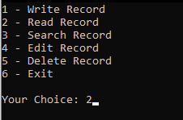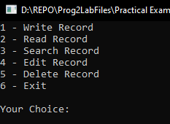**WRITING AD READING:**

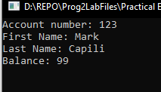

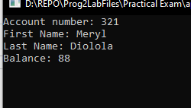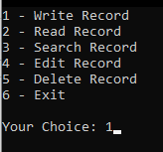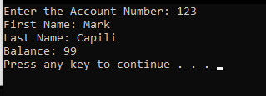

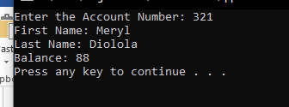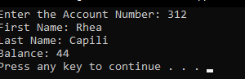

1. **SEARCHING IF ACCOUNT NUMBER EXIST:**



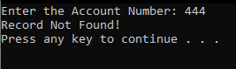

1. **EDITING AND ADDING RECORDS:**

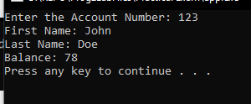**After editing: (used read function)**

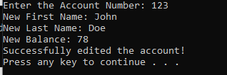

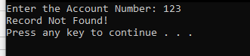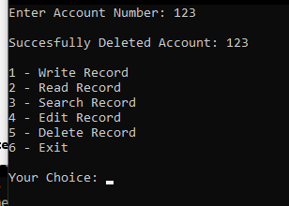 **Use search if account number 123 is still exist**

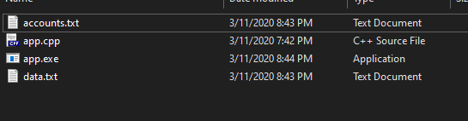**What’s happening in the folder while deleting and editing…**

